Terrain-Integrated Launch Assist Infrastructure for Orbital Vehicles

A Conceptual Framework for Decoupling Initial Δv from Onboard Propellant
Author:
Dr. Delyone de Paula Canedo Filho
Keywords
launch assist
rocket equation
orbital launch systems
space infrastructure
delta-v optimization
space logistics

Abstract
* This work presents a conceptual analysis intended to explore system-level implications of externalized launch energy and does not describe an operational launch system.

The exponential relationship between propellant mass and velocity change imposed by the Tsiolkovsky rocket equation remains one of the primary constraints in chemical launch systems. A substantial fraction of launch vehicle mass is dedicated to propellant required during the earliest phase of ascent, resulting in reduced payload fraction and increased mission cost.

This paper proposes a conceptual launch-assist architecture in which a portion of the initial kinetic energy required for ascent is supplied by reusable ground-based infrastructure integrated into terrain or subsurface structures. By delivering a controlled pre-propulsive velocity increment to a launch vehicle prior to ignition of its primary propulsion system, the approach aims to alter the mass balance of the launch system and improve mission flexibility.

We analyze the physical implications of such an architecture, including acceleration regimes, infrastructure length requirements, and system-level impacts on propellant mass fraction and post-orbit maneuver capability. The concept suggests that even moderate pre-launch velocity increments may significantly influence payload fraction, mission energy budgets, and interplanetary mission design.

1. Introduction

Reaching orbit from Earth requires overcoming both gravitational potential and atmospheric drag while achieving a velocity of approximately 7.8 km/s for low Earth orbit. When gravity losses and aerodynamic losses are included, typical launch vehicles must provide roughly 9.4–9.7 km/s of total Δv.

The governing relationship between mass and velocity in rocket propulsion is described by the Tsiolkovsky rocket equation:

\Delta v = I_{sp} g_0 \ln\left(\frac{m_0}{m_f}\right)

where I_{sp} is the specific impulse, g_0 the standard gravitational acceleration, m_0 the initial mass of the vehicle, and m_f the final mass after propellant consumption.

Because of the logarithmic nature of this relationship, small increases in required Δv lead to disproportionately large increases in propellant mass fraction. Consequently, launch vehicles dedicate the majority of their mass to propellant.

One possible strategy to mitigate this constraint is to externalize a portion of the energy required during early ascent using ground-based infrastructure capable of imparting velocity prior to ignition of onboard propulsion.

This paper explores the feasibility and implications of such an approach.

2. Background and Related Concepts

Multiple proposals have historically explored methods of assisting launch vehicles by providing external energy sources:
- Electromagnetic launch systems
- Mass drivers
- Rotating space tethers
- Launch loops
- Ground-based catapult systems

Each of these concepts attempts to reduce the mass fraction penalty associated with the rocket equation.

However, many of these systems face limitations related to:
- extreme structural scale
- power density requirements
- integration complexity with conventional launch vehicles

An alternative conceptual approach is the use of terrain-integrated infrastructure capable of providing controlled acceleration prior to atmospheric ascent.

3. Conceptual Architecture

The proposed architecture consists of three principal subsystems.

3.1 Terrain-Integrated Acceleration Structure

A long acceleration structure embedded within terrain or subsurface geological formations provides the physical pathway for controlled acceleration prior to atmospheric flight.

Potential advantages include:
- structural confinement
- reduced aerodynamic stress during early acceleration
- infrastructure reuse across launches

3.2 Controlled Energy Transfer

Energy supplied by ground-based systems is converted into a controlled acceleration profile compatible with the structural limits of launch vehicles.

The objective is to transform rapid energy delivery into a distributed acceleration curve along the acceleration structure.

3.3 Vehicle Interface Mechanism

A mechanical interface transfers acceleration to the launch vehicle during the pre-propulsive phase.

Upon exiting the acceleration structure, the launch vehicle transitions to conventional rocket propulsion.

4. Preliminary Physical Analysis

The relationship between acceleration, distance, and velocity can be expressed as:

v^2 = 2as

where v is final velocity, a acceleration, and s distance.

For example, an acceleration regime of approximately 5 g sustained over a distance of approximately 5 km could theoretically provide a velocity increment approaching 700 m/s.

While modest compared with total orbital Δv requirements, such an increment could produce measurable effects on propellant requirements or post-orbit maneuver capability.

5. System-Level Benefits

Propellant Mass Reduction

A pre-launch velocity increment reduces the propellant required during early ascent.

Increased Orbital Maneuver Capability

Alternatively, launch vehicles may maintain the same propellant mass and convert the benefit into additional post-orbit Δv.

Mission Architecture Flexibility

Additional available Δv after orbital insertion may enable:
- faster transfer trajectories
- wider launch windows
- increased payload capability

Logistics Applications

Uncrewed cargo vehicles capable of tolerating higher acceleration may benefit particularly from such launch assistance.

6. Engineering Challenges

Significant engineering challenges must be addressed, including:
- structural loads on launch vehicles
- aerodynamic transition at exit
- thermal effects
- trajectory control
- infrastructure construction feasibility

These factors require multidisciplinary analysis beyond the scope of this conceptual study.

7. Discussion

Launch-assist infrastructure does not aim to replace conventional rockets but rather to augment their performance by providing an initial velocity increment through reusable ground-based systems.

The greatest potential advantage arises when the additional Δv is applied after orbital insertion rather than simply reducing propellant mass.

8. Conclusion

Externalizing a portion of the energy required for orbital launch through reusable infrastructure may significantly alter the economics and performance envelope of launch systems.

Even modest velocity increments prior to engine ignition may produce measurable improvements in payload fraction, mission flexibility, and interplanetary mission capability.

Further research is required to assess structural feasibility, cost-benefit tradeoffs, and integration with existing launch vehicle architectures.

References (placeholder)

Tsiolkovsky, K. E. (1903). Exploration of outer space by means of rocket devices.

Forward, R. L. (1984). Mass driver technology.

Pearson, J. (2004). The orbital tower and launch loop concepts.

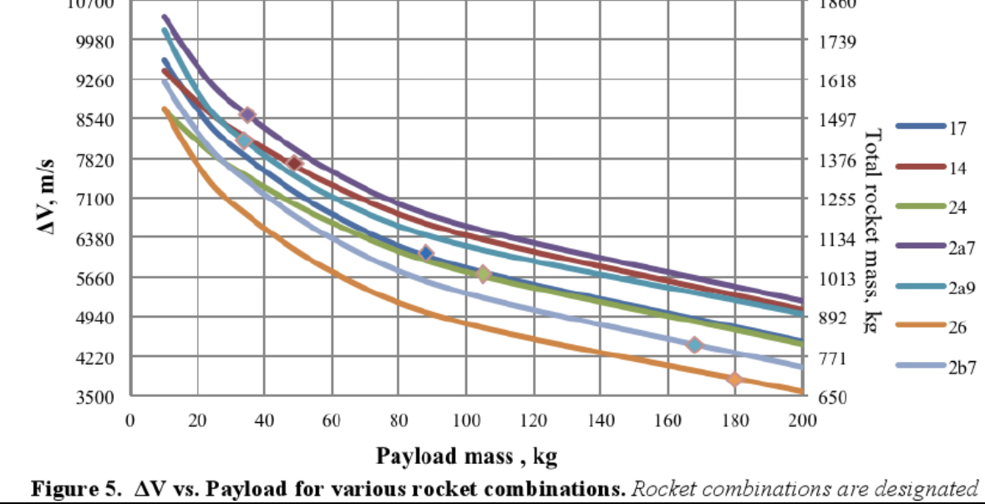
Figura 2 — Relação Δv inicial vs economia de propelente
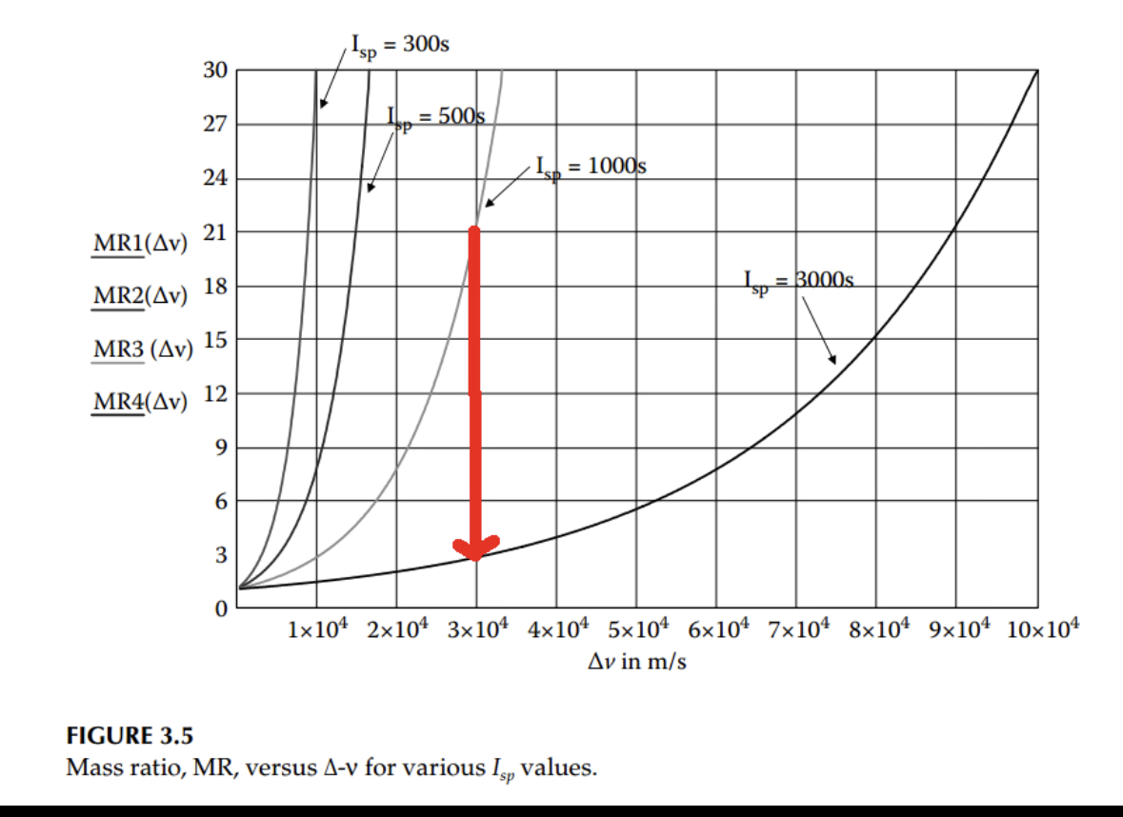
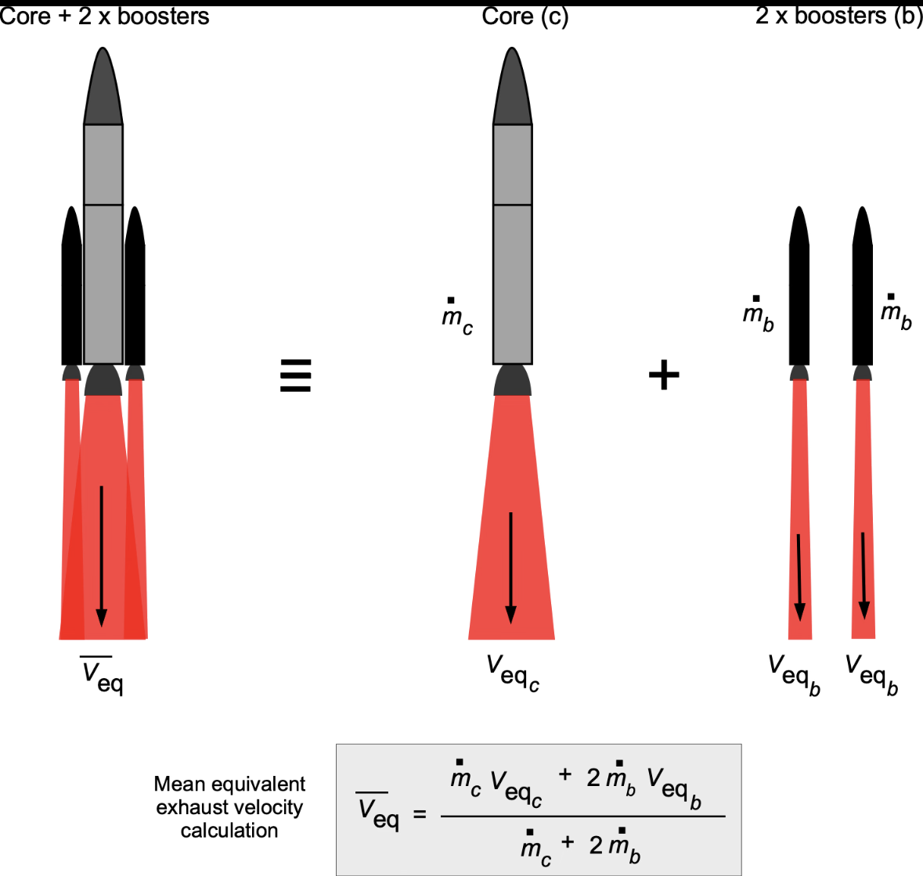
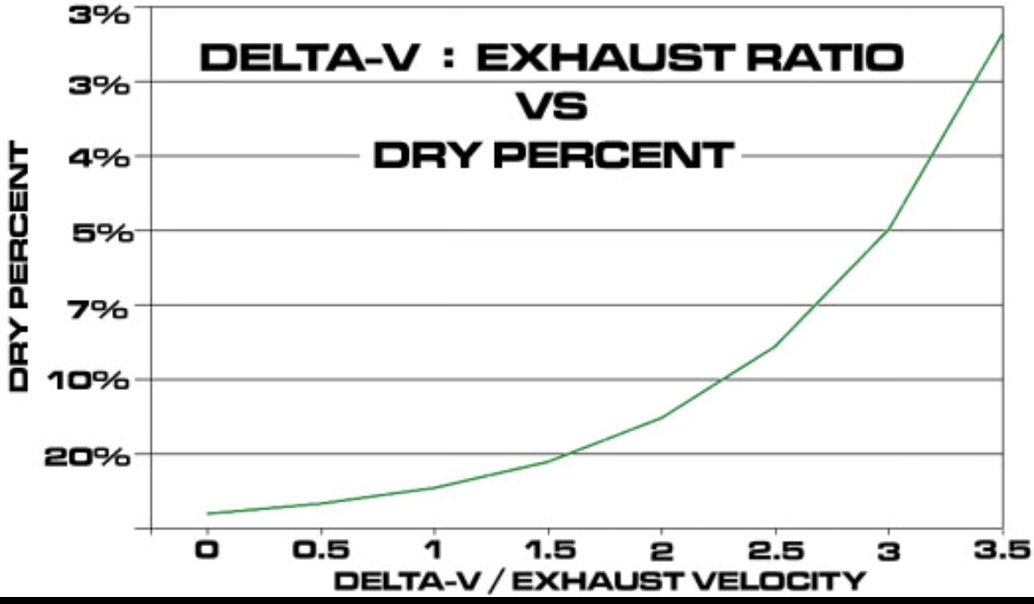

Ideia do gráfico

Eixo X:
Initial external Δv (m/s)

Eixo Y:
Equivalent propellant mass reduction (%)

Valores conceituais que você pode colocar:
Δv inicial | impacto aproximado
100 m/s | ~3–5%
300 m/s | ~8–12%
500 m/s | ~15–20%
700 m/s | ~20–25%

Visualization of System-Level Impact

To illustrate the potential implications of externally supplied initial velocity increments, conceptual plots can be generated comparing initial Δv contributions with equivalent reductions in propellant mass fraction.

Even modest pre-launch velocity increments may produce measurable changes in vehicle mass balance due to the exponential nature of the rocket equation.

